|  |
| --- |
| Policy 5.8  Repair of Rural Fencing Damaged by Bushfire and Fire Control Line Stabilisation |

Policy updated May 2023

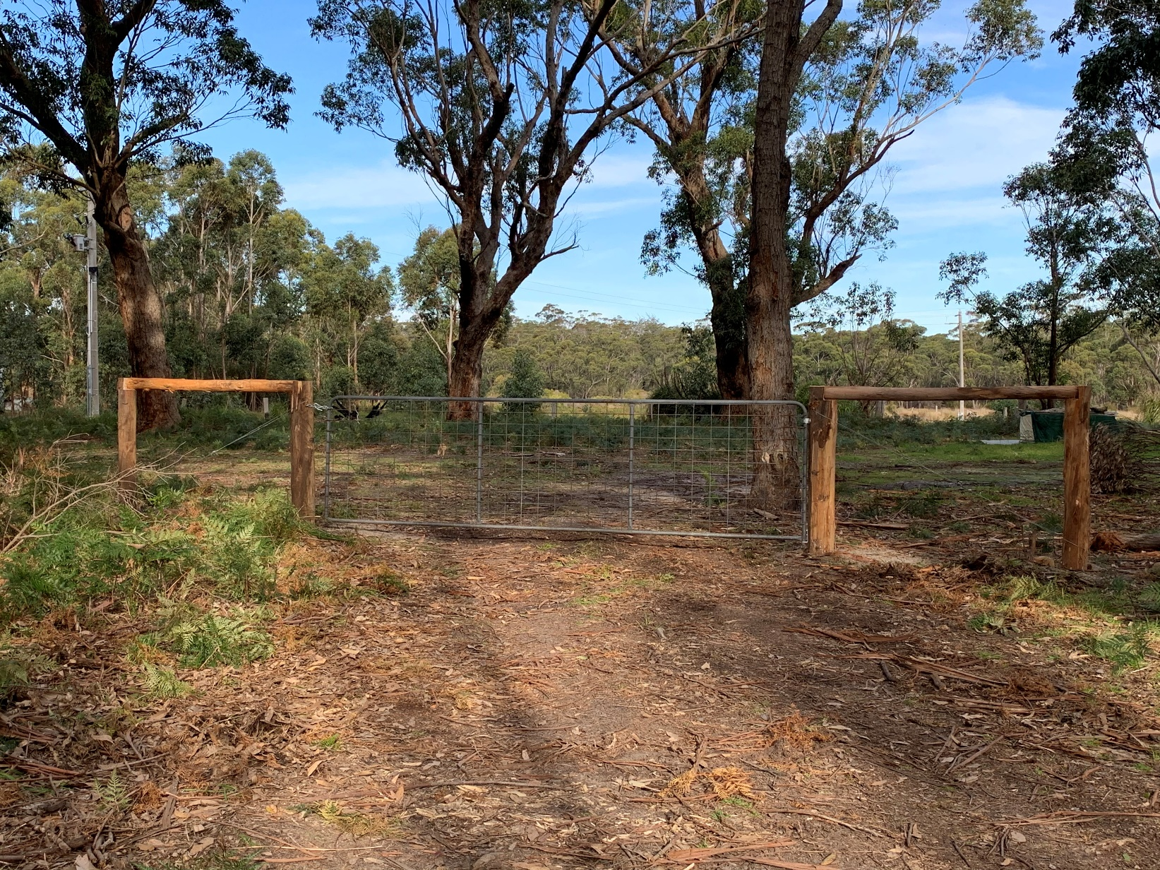

Contents

Contents 1

1.0 Purpose 2

1.1 Background 2

1.2 Purpose 2

1.3 Exclusions 2

2.0 Principles 3

2.1 Repair of fences damaged by bushfire on the boundary of private land and National Park, State Park and State Forest 3

2.2 Repair of fences damaged by fire agency staff or machinery during bushfire emergencies 3

2.3 Stabilisation of fire control lines constructed by fire agencies during bushfire emergencies 4

2.4 Repair of fences damaged by FFMVic or CFA planned burns 4

3.0 Application for assistance 5

3.1 Making an application for assistance under this policy 5

4.0 Examples of different scenarios where this policy may be applied 6

5.0 Glossary 7

# 1.0 Purpose

## 1.1 Background

In Victoria there are approximately 60 000 kilometres of boundary fencing constructed by private landholders along the boundary of public and private land. Bushfire or bushfire suppression activities commonly affect fences. Replacement of fencing is important for marking boundaries, securing stock and access arrangements.

This policy is based on shared responsibility and government encourages landholders to assess and manage their risks with regard to bushfire by taking up adequate insurance where available. Further:

* Landholders are expected to manage risks to their assets from the potential impact of bushfire.
* All landholders are expected to have appropriate levels of insurance cover for boundary and internal fences, in the same way any business venture or private householder should protect and insure their assets.
* In line with the *Fences Act 1968*, the State Government of Victoria does not have any ownership or financial stake in fences along the boundary of private and public land except in cases where specific fencing agreements have been entered into with a landholder.
* It is the responsibility of the owner of private land to fence their property and secure stock within their boundary.
* This policy is intended to assist landholders where other options for support such as insurance aren’t available.
* Section 2.1 of this policy applies to boundary fences. Other government assistance to assist landholders with fence replacement may be available for fence replacement landholders
* This policy does not apply following damage caused by other emergencies such as a flood or storm event.

## 1.2 Purpose

This document establishes a clear and consistent approach to:

1. Repair of fences damaged by bushfire that cross National Park, State Park and State Forest boundaries and adjoining private agricultural land.
2. Repair of fences damaged by fire agency staff or machinery during bushfire suppression activities.
3. Stabilisation of land used as fire control lines by fire agencies in the suppression of bushfires.
4. Repair of fences damaged as a result of planned burning activities.

The policy outlines the responsibilities of the Victorian Government and landholders to support landholder and community recovery from a bushfire incident.

## 1.3 Exclusions

The policy excludes:

* Internal fences on private land, and fences between private properties, damaged by bushfire that is not the result of an escaped planned burn.
* Repair or replacement of any property, or reimbursement for any damage or loss, that is not specifically provided for in section 2.0 .
* Replanting of trees, re-establishment of pasture or agricultural crop.
* Fences covered by a specific fencing agreement between the Victorian Government and a private landholder if there are conditions where they should be managed under that agreement.
* Fences that were not functioning for their intended use before they were damaged.

# 2.0 Principles

## 2.1 Repair of fences damaged by bushfire on the boundary of private land and national park, State park and State forest

The Victorian Government will pay 50% of the reasonable cost of materials to a maximum of $5,000 per kilometre to restore, repair or replace fencing and other fencing assets between private land, including agricultural land and all national parks, State parks and State forests destroyed or damaged by bushfires, whether the bushfire started on private or public land.

Labour and any other costs are to be met by the landholder, and the landholder is responsible for arranging the carrying out of the work. Landholders may also elect at their own expense to upgrade the fence beyond the standard offered as part of the Government’s assistance.

This principle:

Only applies to fencing and other fencing assets between private agricultural land and all national parks, State parks and State forests. Landholders are responsible for the repair, replacement or restoration of internal fences, or fences between private properties, that have been impacted by bushfire.

Does not apply to riparian fences unless they are on a boundary between agricultural private land and national park, State park or State forest.

## 2.2 Repair of fences damaged by fire agency staff or machinery during bushfire emergencies

In the event of bushfires that start on public land, the Victorian Government will arrange for the works to be carried out and pay 100% of the reasonable cost to restore, repair or replace fences and other fencing assets on private land damaged as a result of machinery used by fire agencies to control bushfires, or fire agency staff cutting through fences to allow access for suppression efforts.

This principle:

* Applies to internal fences, fences between private properties and boundary fences between private and public land
* Includes damage to fences by machinery such as bulldozers entering the property and/or constructing fire control lines, and other fire emergency vehicles obtaining access
* Excludes damage to fencing caused by backburning utilised as a bushfire suppression tool. Fences damaged by backburn are treated the same as damage by bushfire

In the event of bushfires that start on private land that is under the control of the Country Fire Authority (CFA) or Fire Rescue Victoria (FRV) the control agency will provide some limited assistance for the repair to fences damaged by machinery. The Department of Energy, Environment and Climate Action (DEECA) will assist the CFA and FRV with fencing works if requested to do so.

## 

## 2.3 Stabilisation of fire control lines constructed by fire agencies during bushfire emergencies

In the event of bushfires that start on public land, the Victorian Government will assist private landholders with the stabilisation of fire control lines, established by fire agencies, during the suppression of bushfires.

In the event of bushfires that start on private land and are under the control of the CFA or FRV, the CFA or FRV will provide some limited assistance for the stabilisation of fire control lines. DEECA will assist the CFA and FRV with control line stabilisation works when requested to do so.

Fire control line stabilisation involves pushing back top soil and undertaking erosion control measures to protect the land from soil erosion and protect water quality but excludes reseeding or replacing crops.

## 2.4 Repair of fences damaged by FFMVic or CFA planned burns

The Victorian Government will arrange for the works to be undertaken and pay 100% of the reasonable costs to restore, repair or replace fences and other fencing assets directly destroyed or damaged by planned burns.

This principle:

Applies to internal fences, fences between private properties and boundary fences between private land and all public land.

*Notes*

* *FFMVic planned burns are undertaken as part of the yearly planned burning program.*
* *Repair of fences damaged by authorised CFA planned burns when under control of CFA should be referred to the local CFA District Office.*
* *Backburns utilised by fire agencies as a bushfire suppression tool are not considered FFMVic or CFA planned burns and damaged fences are treated the same as fences damaged by bushfire.*

# 3.0 Application for assistance

## 3.1 Making an application for assistance under this policy

All damaged or burnt fences must be assessed by the lead agency (DEECA, CFA or FRV) before any offer of financial assistance can be made and before the fence can be restored, repaired or replaced. Fences, once restored, repaired, or replaced will remain an asset of the landholder for which the lead agency or State Government will have no financial stake, or any on-going maintenance responsibility or liability.

Landholders should determine whether fence restoration costs can be claimed under their insurance prior to applying under this policy.

The landholder’s insurer cannot claim against the Victorian Government for any assistance offered by this policy. If the landholder holds insurance coverage for fences, this should be utilised in first instance. Applications must be lodged by the landholder.

The Victorian Government may decline to make any payment or undertake fence restoration work under this policy where a landholder is claiming or has claimed such costs under their own insurance arrangements or other Government schemes or programs for the relevant damage or loss.

Applications for assistance MUST be lodged with DEECA, CFA or FRV within 12 months of the bushfire or escaped planned burn incident.

* If the fire started on **public land** you will be put in contact with the local DEECA office who will help you OR visit: <https://www.ffm.vic.gov.au/recovery-after-an-emergency/public-land-recovery>.
* If the fire started on **private land**, you will be put in contact with your local CFA or FRV District Operations Manager who will help you.

To access this program or find out more call DEECA’s Customer Contact Centre on **136 186** Monday to Friday, 8am to 6pm – they will help you connect with the DEECA fencing coordinator in your region.

##### Expectations of landholders

Landholders are expected to:

* Manage their risks and have an appropriate level of insurance for the potential impact of bushfire in the same way any business venture or private householder should protect and insure their assets, including fences.
* Apply for assistance within 12 months of the bushfire.
* Provide and substantiate information relating to the damage and the type of fencing on the property.
* Provide access to the property for assessment of damaged fences and completed works.
* Show safe and respectful conduct, acting in good faith.

# 4.0 Examples of different scenarios where this policy may be applied

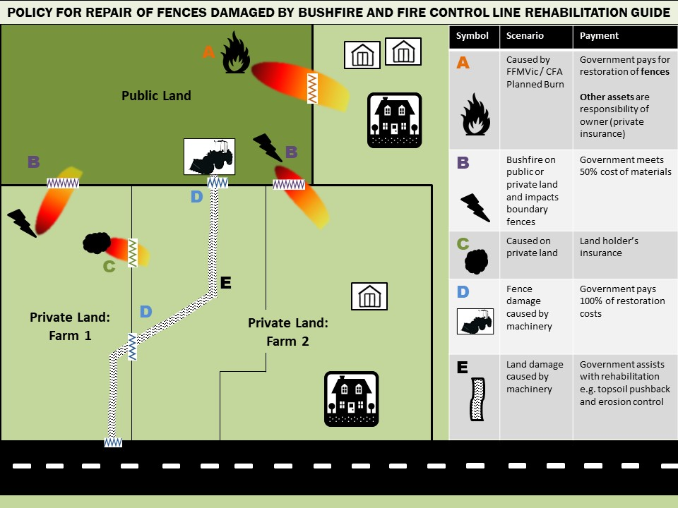

# 5.0 Glossary

|  |  |
| --- | --- |
| Term or phrase used in this policy | Definition |
| Agricultural land | Land used primarily for agricultural or pastoral purposes, regardless of whether the land is also used for commercial or residential purposes; (*Fences Act 1968*). |
| Backburn | An indirect attack tactic where a controllable fire is ignited along the inner edge of a fire control line to consume the fuel in the path of a bushfire, producing a burnt area to expand the depth of the fire control line. |
| Boundary fencing | Fencing constructed along the boundary of private land and national parks, State forests and State parks. It **does not** include boundary fences between two private landholders or other crown land such as road reserve boundary fences. |
| Bushfire | An un-planned vegetation fire in forest, grass or scrub country. |
| Internal fencing | Fencing constructed on private land that does not have a boundary with national parks, State forests or State parks. This includes fences between private properties. |
| Other fencing assets | Other fence parts such as end assemblies, gates and grids. |
| Planned burning | The deliberate application of fire under specified environmental conditions to a predetermined area and at the time, intensity and rate of spread required to achieve planned resource management objectives. A planned burn does not include a backburn undertaken as part of fire suppression operations. |
| Public land | National parks, State forest and protected public land within the meaning of the *Forests Act 1958*. |
| Reasonable restoration costs | Like for like restoration of fences and other fencing assets |
| Specific fencing agreements | Where DEECA or Parks Victoria have an operational requirement for the public land/private land boundary fence (e.g. for environmental protection works), the agencies may at times enter into individual agreements with landholders regarding the sharing of costs of installation and/or ongoing maintenance of a boundary fence. The most common agreement is where DEECA pays for the installation, on the condition the landholder maintains the fence and takes up adequate levels of insurance on an ongoing basis for that fence. |