|  |
| --- |
| Replacement of Essential Water Used During Bushfire Fighting Operations |



|  |
| --- |
| Photo: Ian Gill |

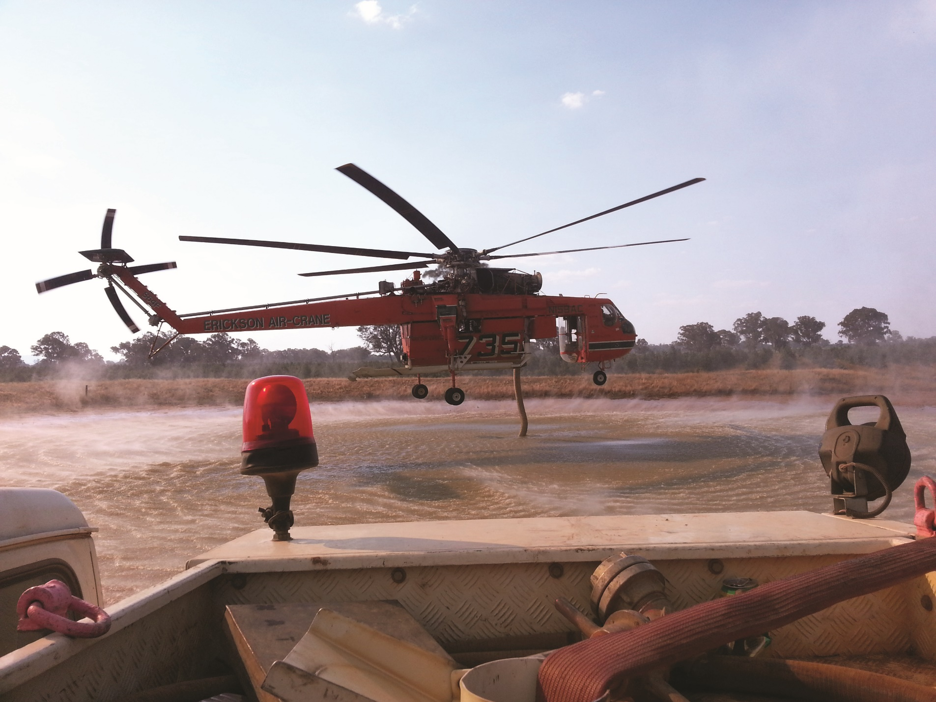

Contents

1. Background 3

2. Purpose 3

3. Glossary of definitions 3

4. Scope 3

5. Procedure 4

5.1 Policy 4

5.2 Implementation 4

5.3 Principles 4

6. General Questions 5

# 1. Background

The *Country Fire Authority Act 1958* (s30 and s32) provides powers to the Country Fire Authority (CFA) and the Department of Energy, Environment and Climate Action (DEECA) to take water from any waterway or any other water supply on public and private land for firefighting purposes.

The Essential Water Replacement Scheme was introduced following the 2006-07 Great Divide Bushfires and was subsequently enacted in following years due to drought conditions across the state. The scheme was put in place for the replacement of essential water used during bushfire operations by Victoria’s fire agencies.

In October 2010, the Victorian Government’s Emergency Management Council endorsed the Essential Water Replacement Scheme as ongoing and is in place regardless of drought conditions. The scheme is implemented as part of the state emergency relief and recovery arrangements outlined in the State Emergency Management Plan (SEMP).

# 2. Purpose

This policy outlines the requirements of the Essential Water Replacement Scheme.

The policy recognises that CFA and DEECA are empowered under legislation to take water from private properties, however where the water has been taken from domestic, stock or irrigations dams and is essential for:

* the health of affected residents and pets;
* the health and productivity of their stock; and
* agricultural and horticultural crops, permanent plantings, and intensive industries,

the water is to be replaced as soon as practical.

# 3. Glossary of definitions

|  |  |
| --- | --- |
| Term | Definition |
| Essential water | Water required to sustain:   * the health of affected residents and pets; * the health and productivity of their stock; and * agricultural and horticultural crops, permanent plantings and intensive industries. |
| Landholder | This means an owner of the land in freehold, or an occupier of freehold or Crown Land whether by lease, licence or other right and who are the users of the essential water. |
| Forest Fire Management Victoria (FFMVic) | Forest Fire Management includes DEECA, Parks Victoria, Melbourne Water and VicForests. |

# 

# 4. Scope

The policy relates to bushfire emergency events only and the use by CFA and DEECA/FFMVic fire fighters of Essential Water obtained from private properties for bushfire suppression or operations, i.e., the taking of water from agricultural dams and household water tanks for firefighting.

The policy does not include emergency arrangements relating to disruption of domestic water supply or sewage services which are handled under other arrangements outlined in the SEMP.

This policy does not include operations undertaken by Fire Rescue Victoria unless its crews are assisting CFA and/or DEECA. Interstate/International crews assisting CFA and/or DEECA are covered by this policy.

# 5. Procedure

## 5.1 Policy

In the event of fire regardless of where it starts, if Essential Water is taken from domestic tanks and stock or irrigation dams for firefighting purposes, water needed for essential use will be replaced (quantity taken) when requested by the landholder.

## 5.2 Implementation

This policy is underpinned by the understanding that bushfire risk is a shared responsibility between government, community and individual landholders. It is implemented as part of the state emergency recovery arrangements and Municipalities/Agencies roles are assigned consistent with the SEMP.

This policy is well communicated and understood within Victoria, as well-informed individuals, landholders, and businesses are best placed to assess and manage their own exposure to the risk of bushfire.

This policy provides authorisation to municipalities to process water cartage costs on DEECA’s behalf for the replacement of Essential Water to landholders.

CFA/DEECA can afford flexibility and discretion to negotiate settlements with landholders to cater for local variations and individual circumstances. If a difference or dispute arises, CFA/DEECA or the landholder must notify the other in writing. Landholders are to contact their local CFA/DEECA office for further information.

## 5.3 Principles

The policy will be implemented in accordance with the following principles:

* Essential Water replaced will not exceed volumes taken by bushfire operations.
* The landholder is required to contact either DEECA or their local municipality if essential water is taken for firefighting purposes.
* Essential Water supplies will be replenished if it is taken for firefighting purposes and there is a request made by the landholder for a replacement of the water.
* Where Essential Water has been completely exhausted, it will be replaced within 48 hours of the need being established where possible. Should operational issues impact on this, relevant emergency management personnel will negotiate the timing of the replacement and address the most immediate priorities.
* Applications by a landholder for the replacement of Essential Water will not be accepted 3 months after the bushfire event other than in exceptional circumstances.

# 6. General Questions

Q: Do the CFA and DEECA have a right to take water from my property?

A: Yes, the *Country Fire Authority Act 1958* (s30 and s32) provides powers to the CFA and DEECA to take water from any waterway or any other source of water supply, without any person being liable to any penalty or claim.

Q: How much water can the Erickson Air Crane (Elvis-type helicopter) pick up in one stop?

A: Approximately 9,000 litres.

Q: Can firefighters take drinking water from my home tank?

A: Yes, in extreme situations where life or property is threatened any water available will be used.

Q: What volume of water is used to fight bushfires?

A: The volume of water used in firefighting operations across the state is relatively small. The government understands what the impact of taking water from farm dams can have in dry conditions. Approximately 12 megalitres in total was used for fighting the Mt Lubra fire in the Grampians in January 2006, which covered more than 120,000 hectares. Following this fire, as part of recovery, arrangements were made through the MECC to replace limited amounts of water taken for firefighting. Local arrangements replaced about 100,000 litres (0.1 ML) taken from private dams.

The Great Divide fires of 2006/07 saw approximately 1,116,000 hectares burnt after 69 days. The estimated water replaced was 10 megalitres.

The 2009 Black Saturday bushfires saw 22 megalitres used.

One megalitre is equal to one million litres.

Ten megalitres equals approximately 4 Olympic sized swimming pools.

Q: What preparations have DEECA and CFA made to ensure there are water supplies during bushfire seasons?

A: 1. Sources of water for firefighting on public land have been mapped statewide.

2. Victoria has Statewide Emergency Water Supply Points for farmers. The Government has

upgraded existing sites and established new sites in consultation with water corporations, the

CFA and DEECA.

3. Within 1-2 km of the coast, sea water may be used for aerial firefighting.

4. DEECA and CFA strategies for ensuring water supply during the bushfire season also include:

* The purchase of additional floating collar tanks/portable dams.
* The establishment of a bulk water carrying fleet to ensure continuity of supply from more reliable water sources during ongoing suppression.
* Working with Local Water Steering Groups to enhance our network of permanent water access through the use of standpipes and access to reticulated reserves and/or tanks and pumps at bores.
* The location of pre-filled reserves (fixed or temporary tanks) in public land areas and at aircraft refilling points.
* The placement of local bulk water tankers on standby to ensure water availability for first attack operations.

Q: Can DEECA and CFA increase their use of dry fire fighting techniques?

A: DEECA primarily uses dry fire fighting techniques however water is still required at times, including for water bombing and extinguishing a new fire while it is still small. Both CFA and DEECA continue to explore fire fighting techniques that use less water. Water is an effective fire fighting tool and can lead to more rapid containment and mop up of bushfires.

Bringing a bushfire under control by rapid and aggressive first attack is a critical part of fire fighting. A fire is easier to control and suppress when it is small. Sourcing water from the nearest source is critical to prevent a fire from spreading.

Q: How does DEECA locate water for fire fighting during a fire?

A: DEECA Water and Catchments Group have identified water points across the state where it is feasible to obtain water for first attack or for a sustained attack on the fire. These points are mostly located on public land i.e., National Parks and State Forest.

Q: If I am not in a drought declared area, will my water still be replaced?

A: Yes, this is a statewide policy and water required for essential stock and domestic services will be replaced.

Q: Will water taken from aesthetic or recreational dams be replaced?

A: As part of the policy, aesthetic or recreational dams are not considered to be used for essential

purposes and therefore water removed for firefighting will not be replaced.

Q: Will all Essential Water taken/exhausted be replaced?

A: The quantity of Essential Water taken for firefighting is the same amount of Essential Water to be replaced. The policy provides for full replacement of Essential Water taken.

Q: Will I get my Essential Water replaced automatically if a card stating that a fire agency took water has been left at my property?

A: No, you still need to submit an Essential Water replacement form to DEECA for DEECA or CFA to process and verify that the water was taken and is essential within 3 months of it being taken.